

**Content Evaluation (MidTerm Test)**

**Pre-Intermediate 1 (Start Up 3 Units 1-2)**

Name: Joaquín Zuleta_______________________ Class: ____English______________ Date: August 29th, 2022______________

Total score: 59 pts. Student score:____________ Grade:_____________%

PRONUNCIATION

A. Listen to the sentences or words. Choose the answer with the correct stress (2 pts)

__a.__ 1. ([Audio track: StartUp3_Unit01_Test_01](https://drive.google.com/file/d/1El-k8nC0kriRa1ujtZ-ZdIEAoOcMjMyi/view?usp=sharing))

a. What are you ***doing*** today? c. What are ***you*** doing today?

b. What ***are*** you doing today? d. ***What*** are you doing today?

__d.__ 2. ([Audio track: StartUp3_Unit01_Test_02](https://drive.google.com/file/d/1CIUtITWzpquI1BgwZEVHWXCYCO2aSLCf/view?usp=sharing))

a. ***I’m*** looking for a job. c. I’m looking ***for*** a job.

b. I’m ***looking*** for a job. d. I’m looking for a ***job***.

GRAMMAR

A. Complete the sentences with the present continuous form of the verb in parentheses. Use a contraction if possible (6 pts)

3. Marty´s looking ____________________ (look) for a new job this month.

4. I´m not joining____________________ (not join) a graphic design class this year.

5. They´re going ____________________ (go) on a family trip at the end of this summer.

B. Complete the sentences with before, after, or when (6 pts.)

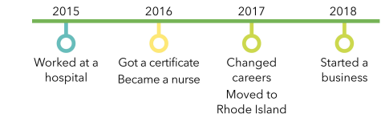

6. Louise moved to Rhode Island __after__________________ she worked at a hospital.

7. Louise changed careers _____before_______________ she started a business.

8. Louise became a nurse _________when___________ she got a certificate.

C. Complete the sentences with ***why don’t***, ***let’s***, or ***let’s not.*** (6 pts.)

9. A: Today is such beautiful weather. ___Let´s_not________________ stay inside all day!

B: OK. We can go for a walk.

10. A: My sister is coming to town this weekend. Should we all do something together?

B: Why don´t_____________ we go get some coffee?

11. A: Do you want to go shopping tomorrow?

B: Good idea. _______Let´s_____________ make a list of what we need.

VOCABULARY

A. Complete the sentences with the correct word(s): (6 pts.)

a. spend time with b. study c. work with

d. take e. play f. look for

__a.__ 12. Tomorrow, I’m going to spend time with_______________ my family. We want to go see a movie.

__e.__ 13. Let’s ___play_________________ soccer outside after we do our homework.

__c.__ 14. It’s nice to ____work with________________ different people at my job.

B. Complete the conversation with the correct phrases: (3 pts)

a. graduated from college b. applied to graduate school c. lost my book

d. got engaged e. quit the job f. start a business

15. A: Jessica! How’s school going?

B: Actually, I graduated from college___________________ last year.

A: Oh, that’s great! Congratulations! So what are you doing now?

B: Thank you. Well I quit the job____________________ I had during school. Now I’m looking for a new place to work. A: Oh, I see. How’s your brother?

B: Good! He’s going to start a business____________________ soon. His store is a few minutes from here.

LISTENING

Listen to the passage and answer the questions. ([Audio track: StartUp3_Unit02_Test_01](https://drive.google.com/file/d/1EMMOvZJGN8NypU9qWU-yXuAzyxVFMVSC/view?usp=sharing)) (3 pts)

a.__ 16. What is the speaker mainly talking about?

a. How you can make friends as an adult.

b. How people spend too much time on the Internet with their friends.

c. How long it takes people to become good friends.

__a.__ 17. Where did the speaker meet one of her best friends?

a. in a group for new mothers

b. on a sports team

c. at a book club

___b._ 18. According to the speaker, what is one thing adults worry about?

a. joining new groups

b. other people’s opinions

c. having enough free time

GRAMMAR

A. Complete each sentence using the correct form of the verb in parentheses + like. (6 pts)

19. A: What did he just say?

B: I’m not sure, but it kind of sounds like____________________ (sound) “Roll.”

20. A: Wow, what a long flight!

B: I know! We arrived in the morning but it feels like___________________ (feel) the evening.

21. A: This kitchen is wonderful.

B: Yes! It smells like___________________ (smell) an old wood stove.

B. Complete each sentence with the correct form of be + the adjective or verb in parentheses. Use contractions when possible. (6 pts.)

22. On the first day of school, he didn’t say anything in class because he was afraid to make a mistake____________________ (afraid / make) a mistake.

23. When you are driving, sometimes the signs on the road aren´t easy to read____________________ (not easy / read), so be careful.

24. I don’t know how to make apple pie, but I´m willing to learn____________________ (willing / learn)!

C. Complete the sentence with the best adverb (3 pts)

a. slowly

d. well

b. carefully

e. badly

c. quickly

__b.__ 25. Please hold this box ____________________. There’s a lot of glass cups in there.

__e.__ 26. I need to use the bathroom ____________________. I haven’t gone in hours.

_c._ 27. Let’s get this done ____________________ before the end of the day.

READING

Read the article and answer the questions.(4 pts.)

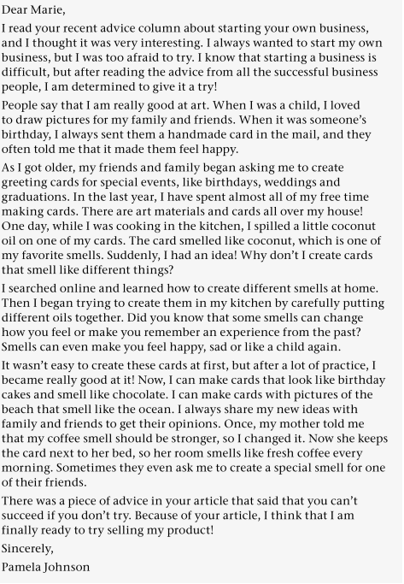

_a.___ 28. Which statement best describes the main idea?

a. Advice can help you try something new.

b. Creating your own product at home is easy.

c. Listen to the opinions of family and friends.

__c.__ 29. How did Pamela get the idea for her product?

a. Her family and friends gave her the idea.

b. She read the idea in an advice column.

c. She thought of the idea after a mistake in the kitchen.

WRITING

1. Choose the best word to complete each sentence (4 pts)

a. so

b. and

c. but

__a.__ 30. Jake Turner is a project manager in East Corp. Jake has a lot of experience, ……he became the manager soon after he joined us.

__b.__ 31. Jake is very hard working and easy to work with, _____ we look forward to continue working with him.

1. Choose the best word to complete each sentence. (4 pts.)

a. During

b. Soon

c. While

d. Then

32. Hey there, How are you doing? I’m in New York City right now with my family. We went on a tour yesterday around the city. ___During_________________ our tour, we visited the college you went to. It was so nice! We’re thinking about watching a play tonight. ______Then______________, I think we are going to try that restaurant you told me about.

Anyways, talk to you soon.

Josh